**FPT ACADEMY INTERNATIONAL**

**FPT – APTECH COMPUTER EDUCATION**

**AURA WATCHES**

|  |  |
| --- | --- |
| **GROUP** | 8 |
| **ADVISOR** | MS. LE MONG THUY |
| **CLASS** | T1.2302.E1 |

**Center Name**: FPT – APTECH HCM – **Address**: 590 Cach Mang Thang Tam, District 3, Ho Chi Minh City

**Group Members (Group 8)**

|  |  |  |
| --- | --- | --- |
| Number | Name | Student ID |
| 1 | Tran Quang Khai (Leader) | Student1457498 |
| 2 | Phan Quoc Huy | Student1457509 |
| 3 | Tran Thi Hue | Student1457508 |

**Duration**

|  |  |
| --- | --- |
| Start Date | End Date |
| 23 May 2023 | 23 June 2023 |

# ACKNOWLEDGEMENT

Our group would like to express my sincere thanks to all the teachers at Ho Chi Minh FPT Education International, and especially the teachers of the FPT Aptech. Thank you, teachers, for wholeheartedly teaching and imparting valuable knowledge to us during our study and training at school, creating conditions for us to encounter reality to shorten the distance between theory and practice, and increasing our knowledge and professional skills. It is the most valuable asset, the luggage for us to step into life and build the future.

We would like to express our deepest gratitude to Ms. Le Mong Thuy, our teacher who enthusiastically guided and guided us throughout the process of making our capstone project. We have been taught us how to look at problems, ask questions, and find ways to solve problems. Seriousness, high independence, meticulousness, and seeing problems from many perspectives.

What we have learned from you, not only imparts knowledge but also has skills at work but also helps us to be more stable in the face of difficulties in life, which is valuable. Once again, we would like to express my sincerest thanks to my teacher.

HCMC, 23rd June 2023

Group 8

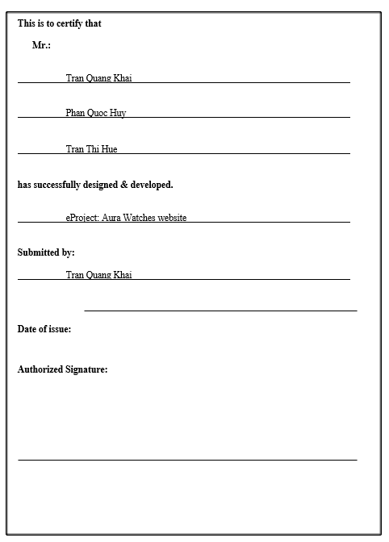

# TABLE OF CONTENTS

ACKNOWLEDGEMENT 2

TABLE OF CONTENTS 4

1. PART 1: PROBLEM STATEMENT 5

1.1 Synopsis 5

1.2 Requirement Specification 5

2. PART 2: E-PROJECT ANALYSIS 6

2.1 Client: Aura Watches 6

2.2 Business/Project Objectives 6

2.3 Input to the System 6

2.4 Output from the System 6

2.5 Hardware and Software Requirements 6

2.6 Scope of Work (in Brief) 7

3. PART 3: E-PROJECT DESIGN 9

3.1 Architectures 9

3.2 Diagram of the Website 10

4 PART 4: TASK SHEET REVIEW 1 11

5 PART 5: SITE MAP AND MOCK OF WEBSITE 13

5.1 Site Map 13

5.2 Mock Pages 14

5.2.1 Home Page 14

5.2.2 Product 15

5.2.3 Blog 16

5.2.4 About Us 17

5.2.5 Contact Us 18

5.2.6 Services 19

5.2.7 Sign In/Sign Up 20

6 PART 6: TASK SHEET REVIEW 2 21

7 PART 7: E-PROJECT IMAGES (SCREEN SHOT) 24

7.1 Home Page 24

7.1.1 Description 24

7.1.2 Screen Shot 24

7.2 Product 26

7.2.1 Description 26

7.2.2 Screen Shot 26

7.3 Blog 27

7.3.1 Description 27

7.3.2 Screen Shot 27

7.4 About Us 27

7.4.1 Description 27

7.4.2 Screen Shot 28

7.5 Contact 28

7.5.1 Description 28

7.5.2 Screen Shot 29

7.6 Service 29

7.6.1 Description 29

7.6.2 Screen Shot 30

7.7 Responsive 30

7.7.1 Description 30

7.7.2 Screen Shot 31

8 PART 8: SOURCE CODE WITH COMMENTS 35

8.1 Slider 35

8.2 Filter 36

8.3 Show Products 36

8.4 Routing 37

8.5 Json Access 38

9 PART 9: TASK SHEER REVIEW 3 39

# PART 1: PROBLEM STATEMENT

## Synopsis

The goal of the e-Project is that we need to create a website that meets all the requirements of the client, Aura Watches. Aura watches is into business of manufacturing and selling watches. They have been advertising about their clocks and watches through newspapers, pamphlets, television. Now with changing times, they have decided to go online as customers today use Internet extensively. They have planned for a website with complete details about their watches and clocks.

## Requirement Specification

The Web site is to be created based on the following requirements:

1. The Home Page should have suitable logo, and decent color combination.
2. The site should display a menu which will contain the options as Products, Technology, Store Locator, Support etc.
3. Various pages having information about different types of watches and clocks, technology used in the watches etc.
4. The information should be categorized according to different Product Line-up e.g., “SPORTZ”, “PREMIER” etc.
5. When a user selects any product line-up, complete list of watches for that product line-up will be displayed.
6. Details of the watches should be displayed on the Web Page along with the title and it should be stored in Individual Word documents which can be downloaded or viewed by the User who wishes to see the same.
7. Price List for all watches should be available for download.
8. There should be a “Contact Us” page which will have the Address of the Stores selling watches and the mail address which when clicked will invoke the local mail client from where they can send an email.

# PART 2: E-PROJECT ANALYSIS



## Client: Aura Watches

## Business/Project Objectives

The company advertises by distributing the pamphlets, advertising on television and so on. Due to rapid development in internet field, the company decides to launch a website where people will get all the information about the various products available with them easily.

You are supposed to create a website for them with the below mentioned requirement specifications.

The website is to be developed for the Web Platform using HTML5, CSS3, JavaScript, Angular. The site should work well in all leading browsers including Chrome, Microsoft Edge, Firefox etc.

## Input to the System

* Searching products based on name, gender, type … and other products.
* Register members on website.
* Feedback about the quality of products

## Output from the System

* Perform search based on brand, product type, color, material...
* Display results for each type of product according to the search content.
* Display product information by price, specifications, brand, image, color, model...
* Display the special information of the product.
* Display products of the same type, same color.
* Display a button so that customers can download the product's catalog.
* Customers can also download the price list of products on the website.
* Site should be able to provide brief introduction/history about the shop under About Us page.
* The location of the shop under Contact-Us page.
* Displays FAQ and allows users to email directly to the company.

## Hardware and Software Requirements

* **Process**: Validate data input from users.

**Expected delivery date**: 22-June-2023.

**List of deliverables:**

- Document Word, PDF.

- User Guide.

- Source code.

**Hardware/ Software Requirements:**

* **For developer**

Hardware

• Intel Pentium 4 processor or higher

• 01 Gigabytes of RAM or higher

Software

• Windows 7 OS or higher

• Adobe Dreamweaver

• Web browsers such as IE, Chrome or Firefox are supporting HTML5, CSS3 and JavaScript.

* **For web users**

Hardware

• Intel Pentium 4 processor or higher

• 512 Megabytes of RAM or higher

Software

• Windows XP OS or higher

• Web browsers such as IE, Chrome or Firefox are supporting HTML5, CSS3 and JavaScript.

## Scope of Work (in Brief)

After a long and detailed discussion, our group has decided to create a website contain the following webpages:

1. Homepage: There is a search bar to search for products, display promotional information, products type and introduce Aura Watches.

2. Shop page: Displays all available products. In the above categories, products can be filtered by name, type, color, gender.

3. Blog: Display articles, news, equipment installation instructions...

4. About Us: Display the information of the company, clients’ review and about us.

5. Contact Us: Display the address of the company, Map and allow customers to request any information they want to Aura Watches.

6. Service: Displays user inquiries, product documents, and product price lists for user downloads, freight services, and equipment installation.

7. Sign In/ Sign Up: Allow users sign up or sign into the website.

# PART 3: E-PROJECT DESIGN



## Architectures

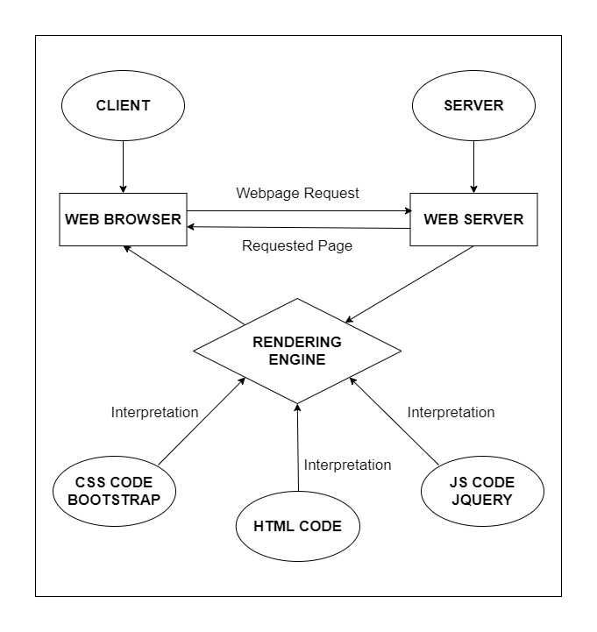

## Diagram of the Website

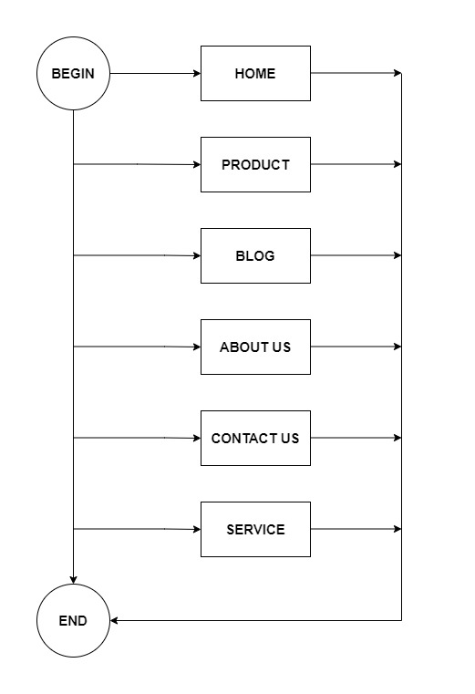

# PART 4: TASK SHEET REVIEW 1

|  |  |  |  |  |  |  |  |
| --- | --- | --- | --- | --- | --- | --- | --- |
| **Project Ref. No.:**  **eP/Advertisement Portal Management**  **System/01** | | **Project Title:** | **Activity Plan Prepared By:** | **Date of Preparation of Activity Plan:** | | | |
| **Sr.**  **No.** | **Task** | **Actual**  **Start**  **Date** | **Actual Days** | **Team**  **Mate Names** | **Status** |
| 1 | Problem Statement | AURA WATCHES | Khai | 14-June-23 | 1 | Khai | Completed |
| 2 | Analysis of Aura Watches requirements about the website | 14- June -23 | 1 | Khai | Completed |
| 3 | The scope of the work (in brief) | 14- June -23 | 1 | Huy | Completed |
| 4 | Architecture and design of the system | 14- June -23 | 1 | Huy | Completed |
| 5 | Diagram of the website | 14- June -23 | 1 | Hue | Completed |
| 6 | Task Sheet | 14- June -23 | 1 | Hue | Completed |

|  |  |
| --- | --- |
| **Date:** | |
| Signature of Instructor  Ms. Le Mong Thuy | Signature of Team Leader  Tran Quang Khai |

# PART 5: SITE MAP AND MOCK OF WEBSITE

## Site Map

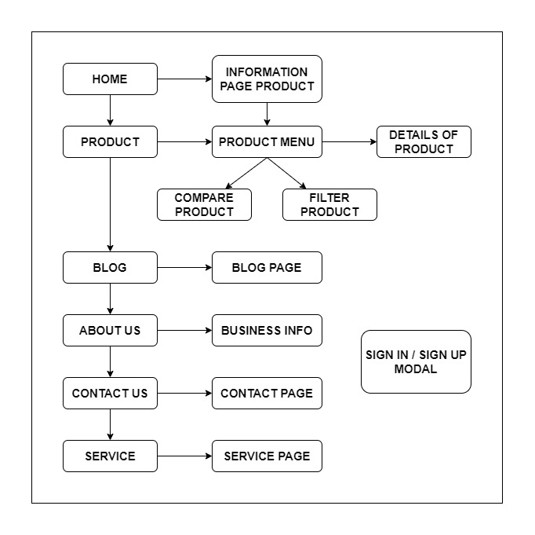

## Mock Pages

### Home Page

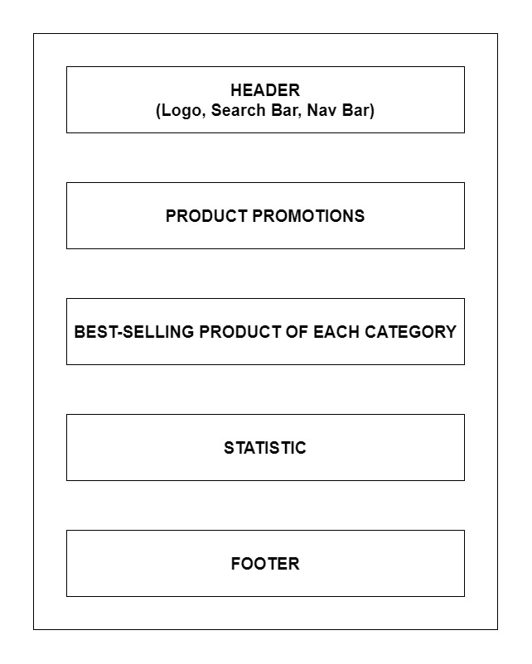

### Product

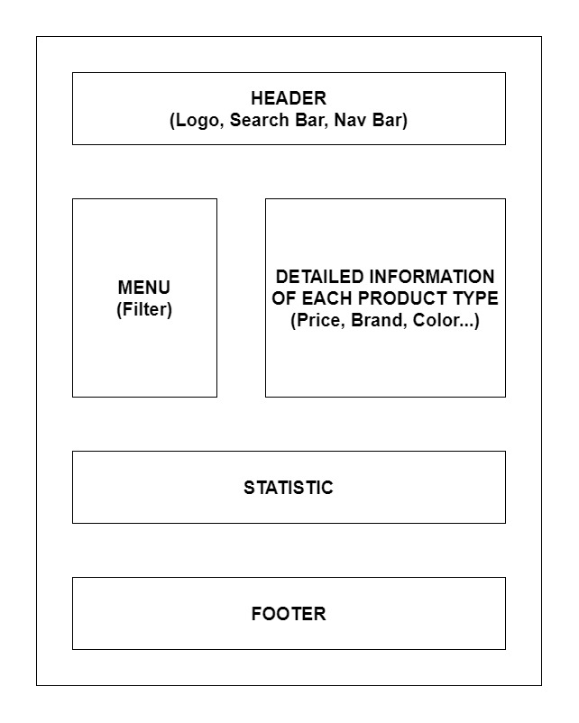

### Blog

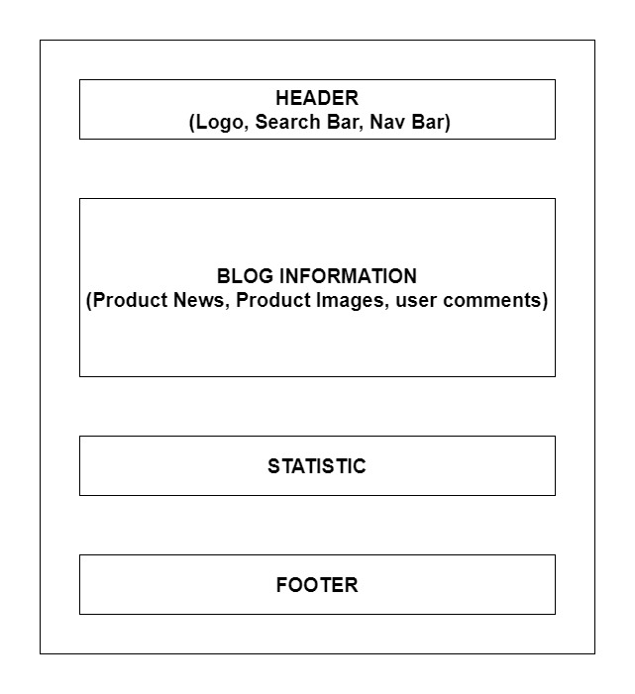

### About Us

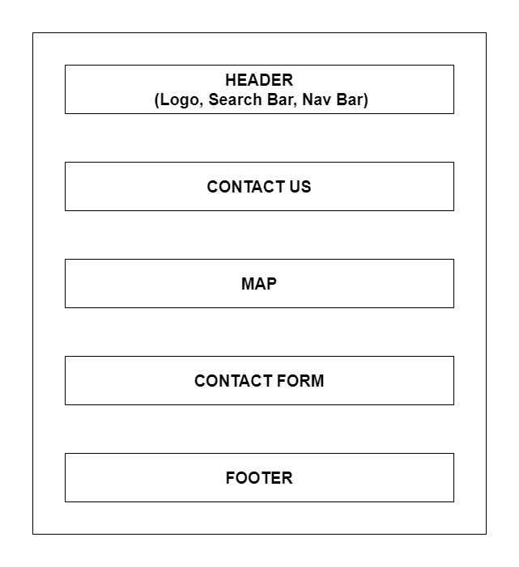

### Contact Us



### Services

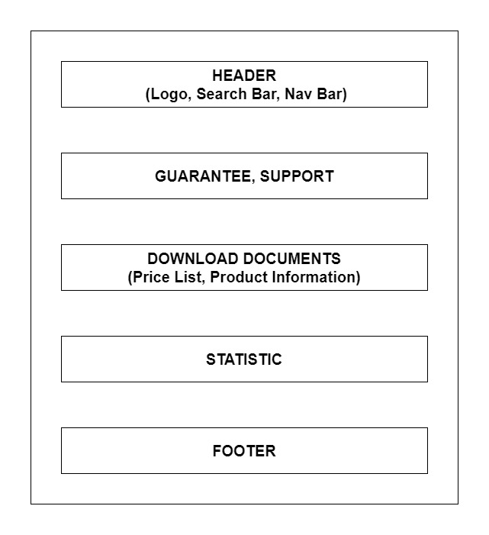

### Sign In/Sign Up

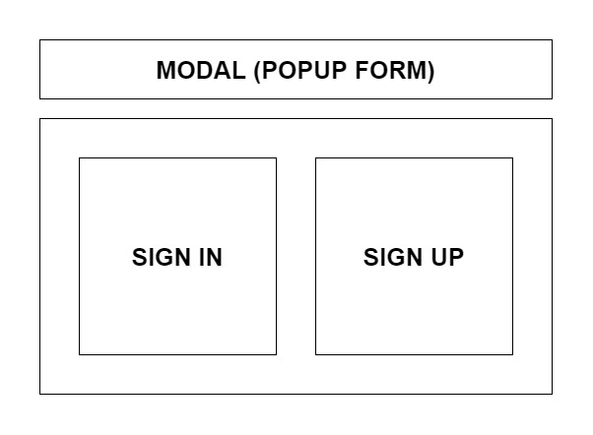

# PART 6: TASK SHEET REVIEW 2

|  |  |  |  |  |  |  |  |
| --- | --- | --- | --- | --- | --- | --- | --- |
| **Project Ref. No.:**  **eP/Advertisement Portal Management**  **System/01** | | **Project Title:** | **Activity Plan Prepared By:** | **Date of Preparation of Activity Plan:** | | | |
| **Sr.**  **No.** | **Task** | **Actual**  **Start**  **Date** | **Actual Days** | **Team**  **Mate Names** | **Status** |
| 1 | Site Map | AURA WATCHES | Khai | 16-June-23 | 1 | Khai | Completed |
| 2 | Mock of the website | 16- June -23 | 2 | Huy | Completed |
| 3 | Task sheet | 16- June -23 | 2 | Hue | Completed |

|  |  |
| --- | --- |
| **Date:** | |
| Signature of Instructor  Ms. Le Mong Thuy | Signature of Team Leader  Tran Quang Khai |

# PART 7: E-PROJECT IMAGES (SCREEN SHOT)

## Home Page

### Description

Home page displays following information:

- Slide show programs, services, and product promotions

- Feature product.

- Latest news (Blog).

- Popular Brand.

- Some information about the website.

### Screen Shot

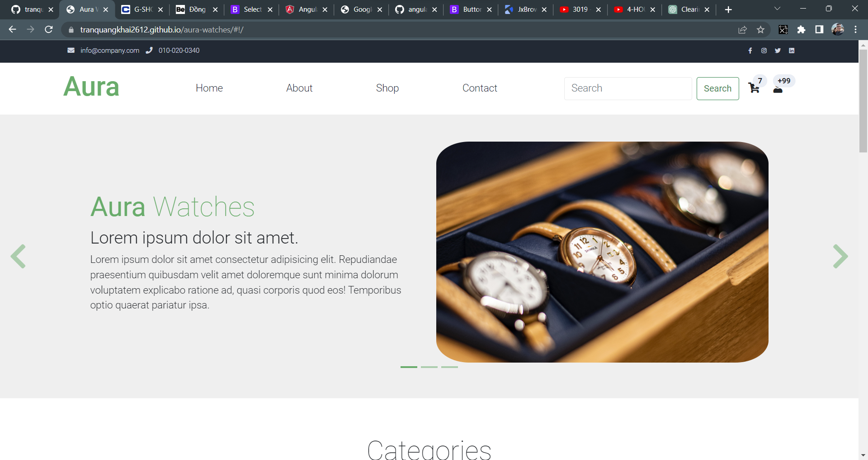

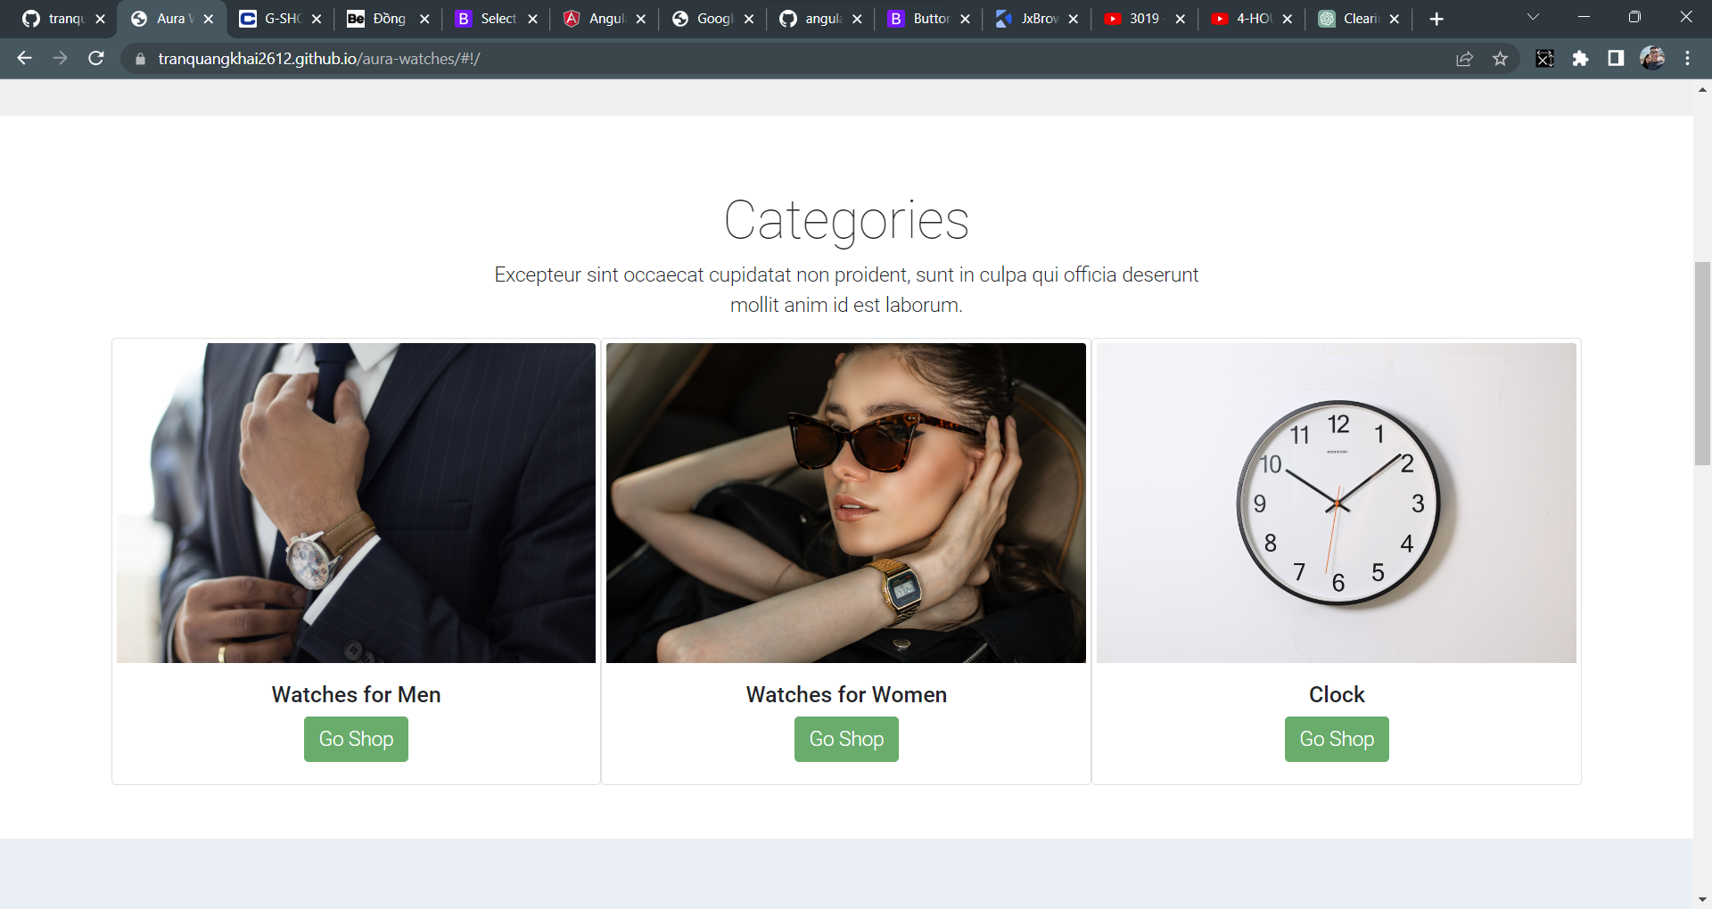

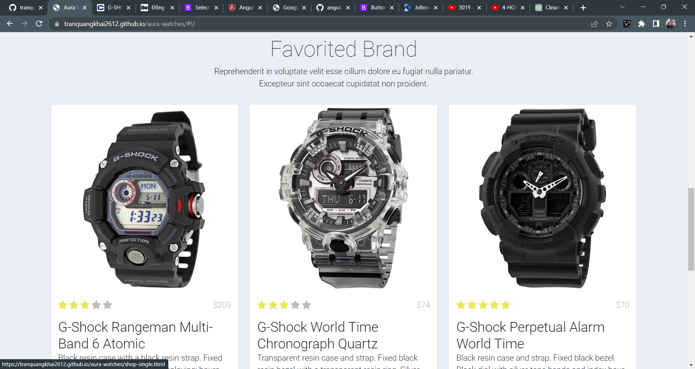

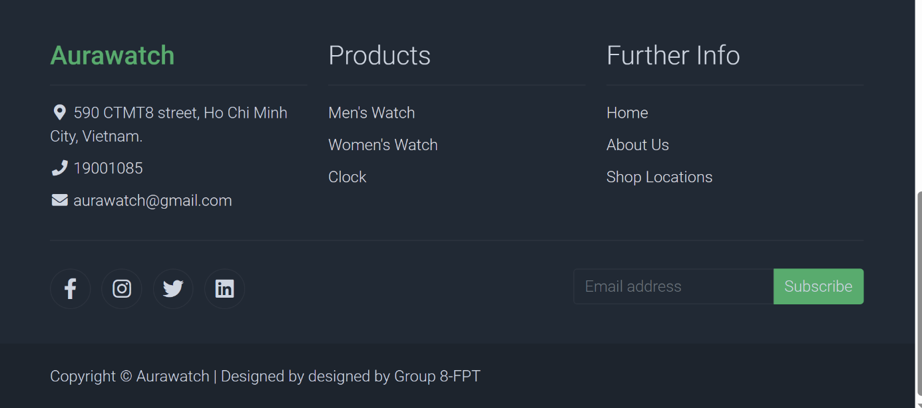

## Product

### Description

This product page displays following information:

- All product that being sold at Aura Watches, when click on quick view item, it will show the detail of that item.

- Menu filter to easily find items based on categories.

### Screen Shot

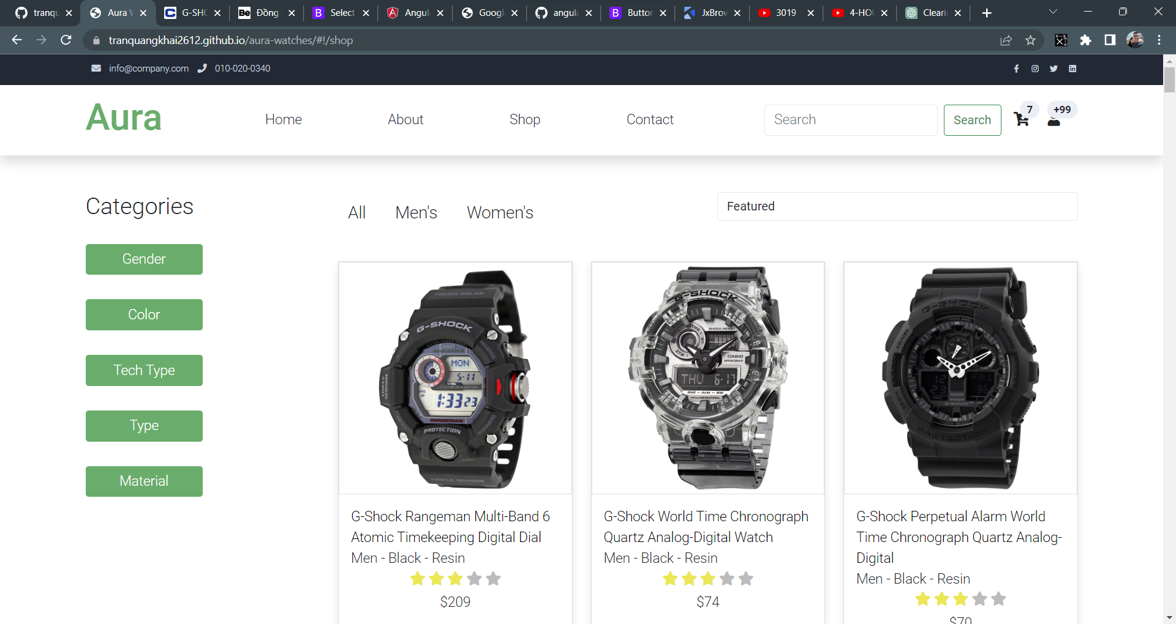

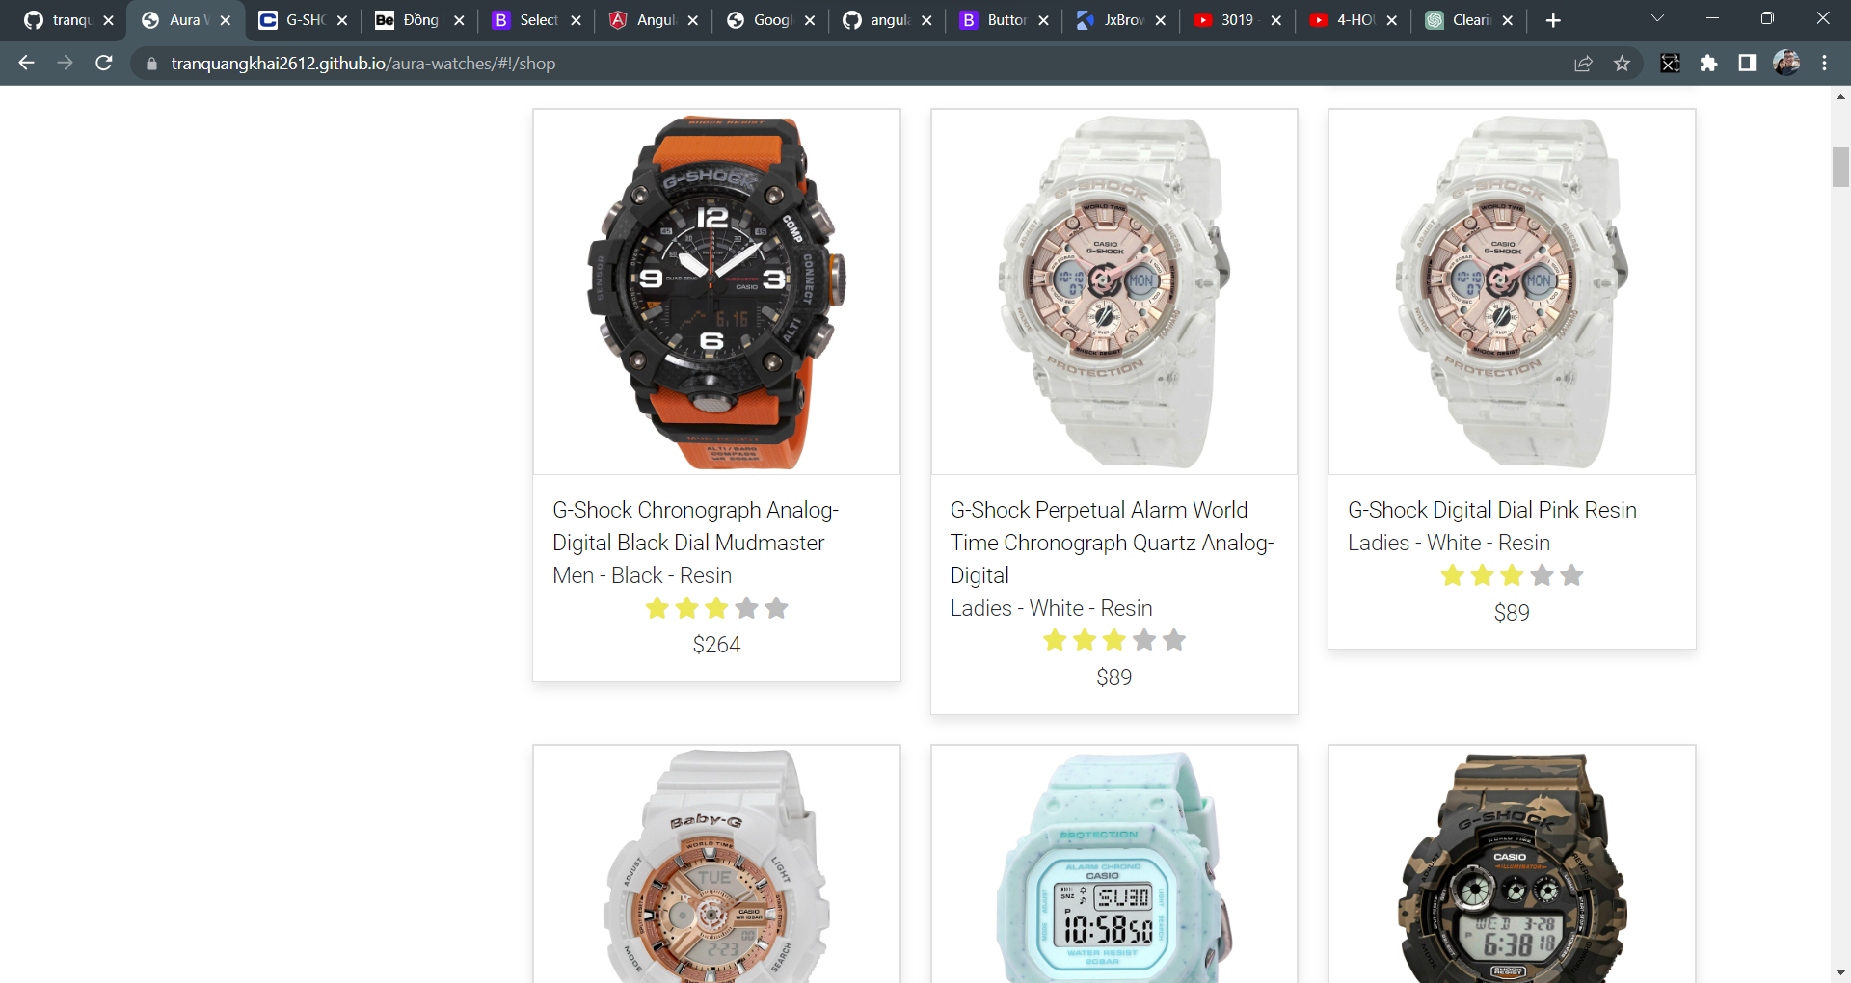

## Blog

### Description

The blog page displays following information:

- News.

- Information of product.

- Events, promotion.

### Screen Shot



## About Us

### Description

- This page displays information about values, our service that we provide and our team member.

- Display happy customer.

### Screen Shot

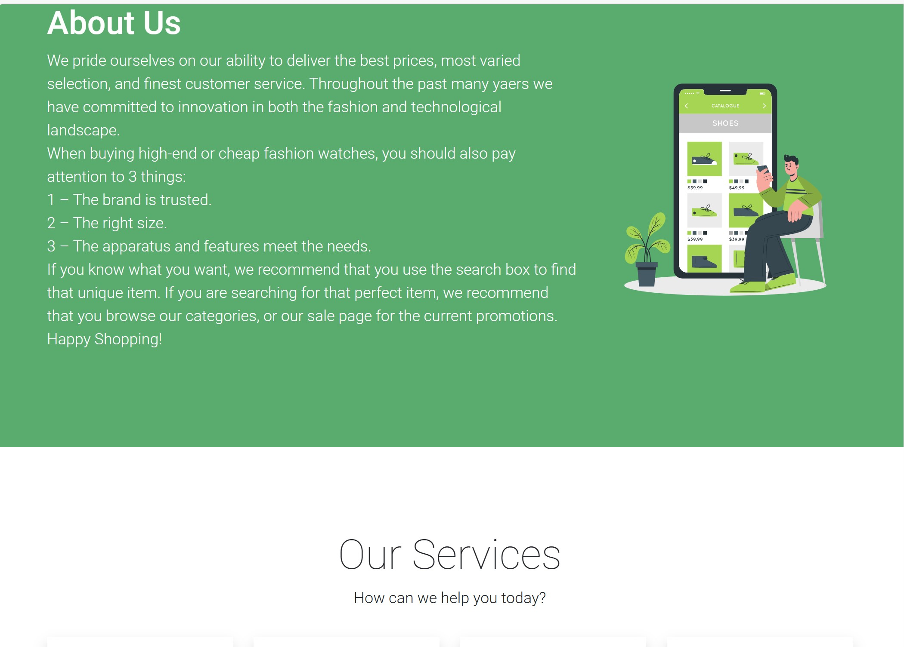

## Contact

### Description

This page displays contact information: location, telephone number, email and a quick contact form for customer

### Screen Shot

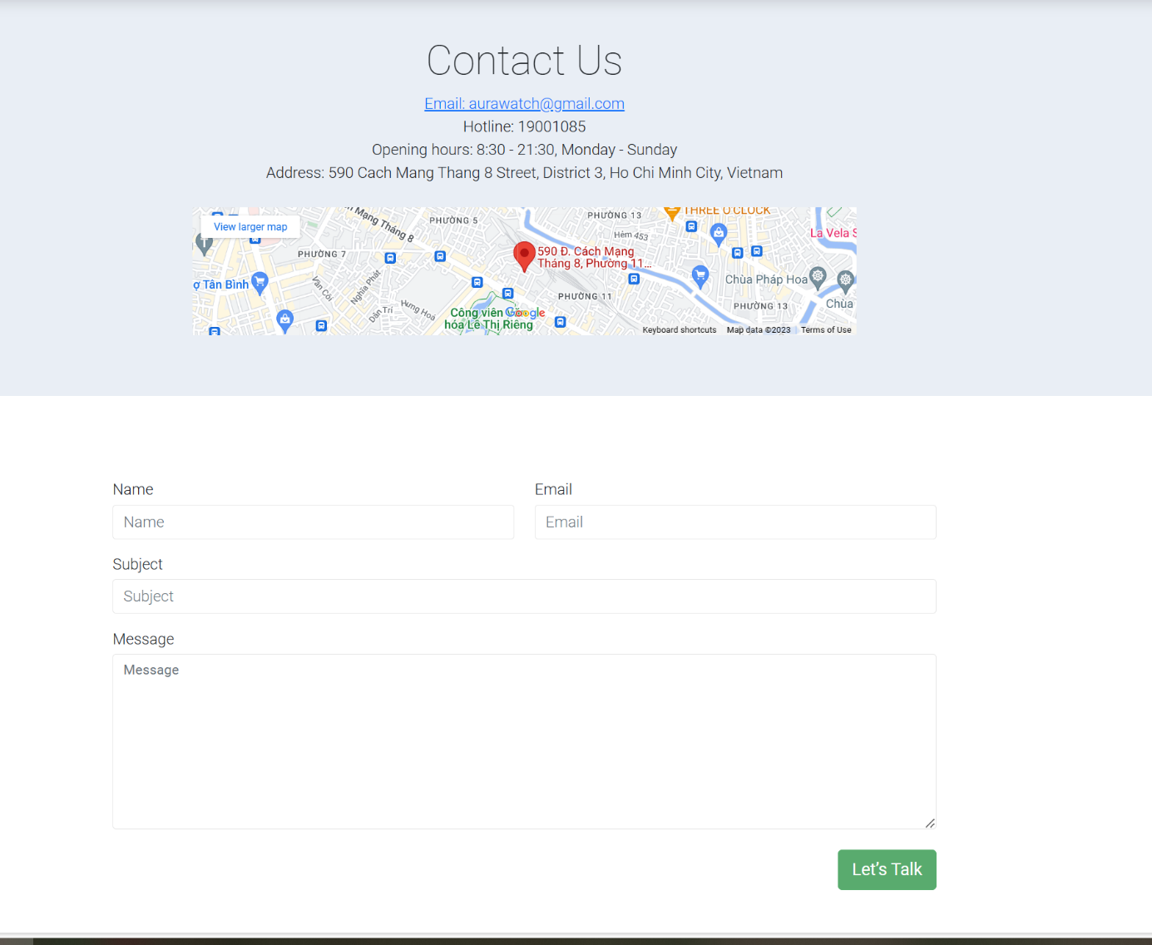

## Service

### Description

- This page displays information: Warranty terms, information, review about product.

- User can download product data.

### Screen Shot

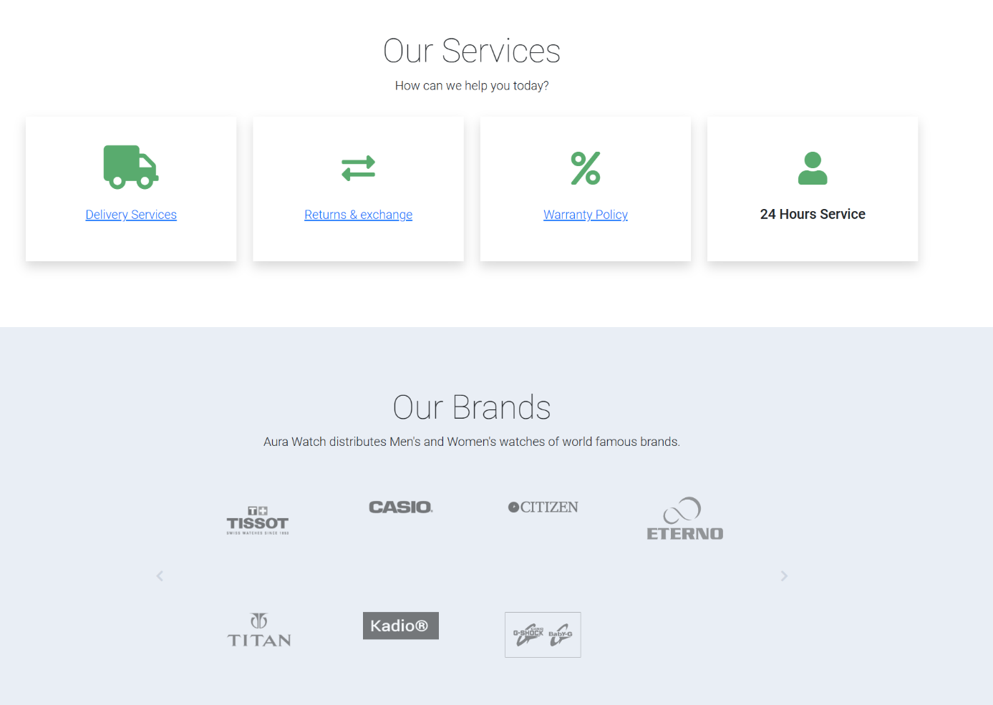

## Responsive

### Description

The page has responsive feature for small screen device such as smart phone, tablet, etc.

### Screen Shot

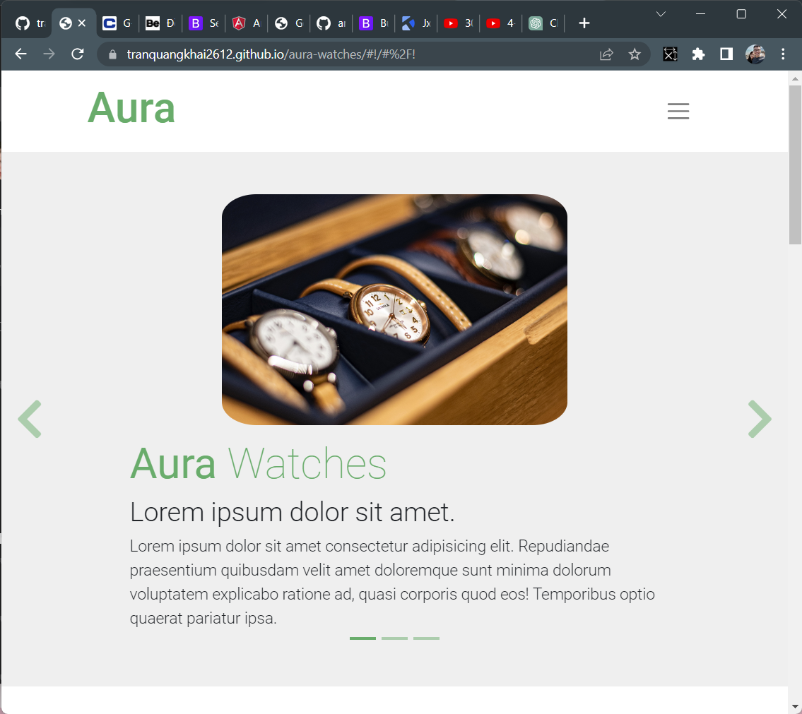

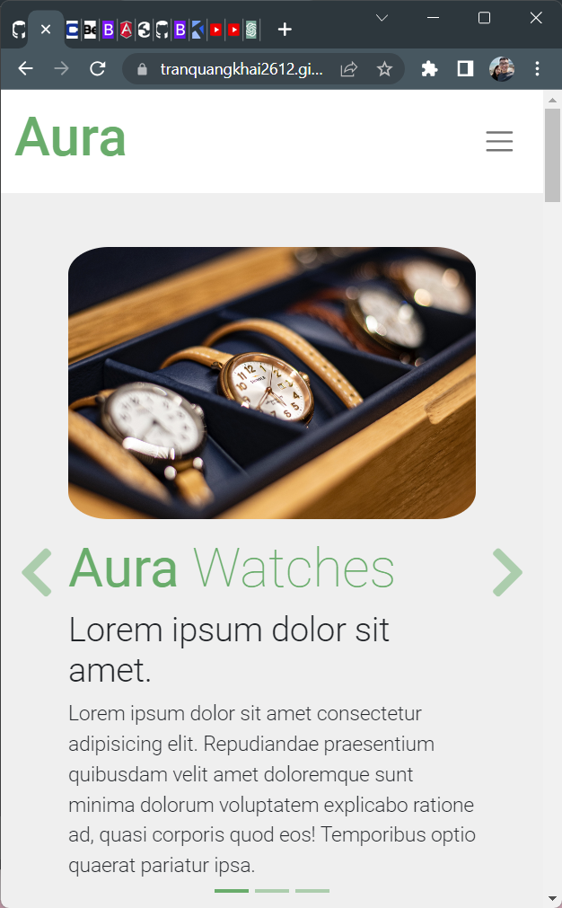

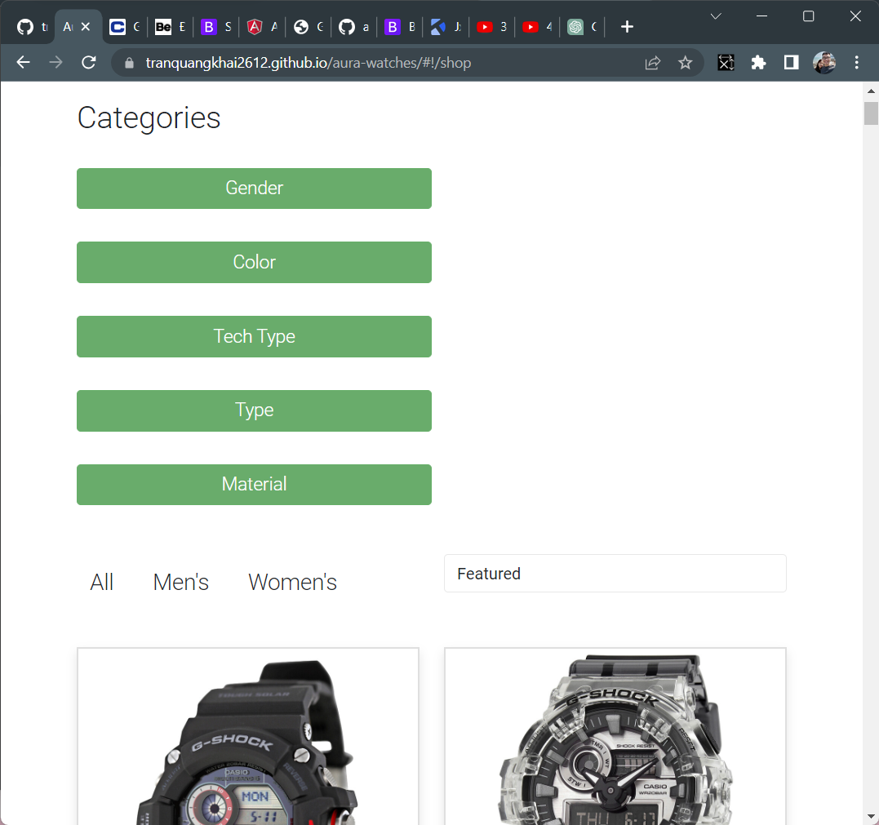

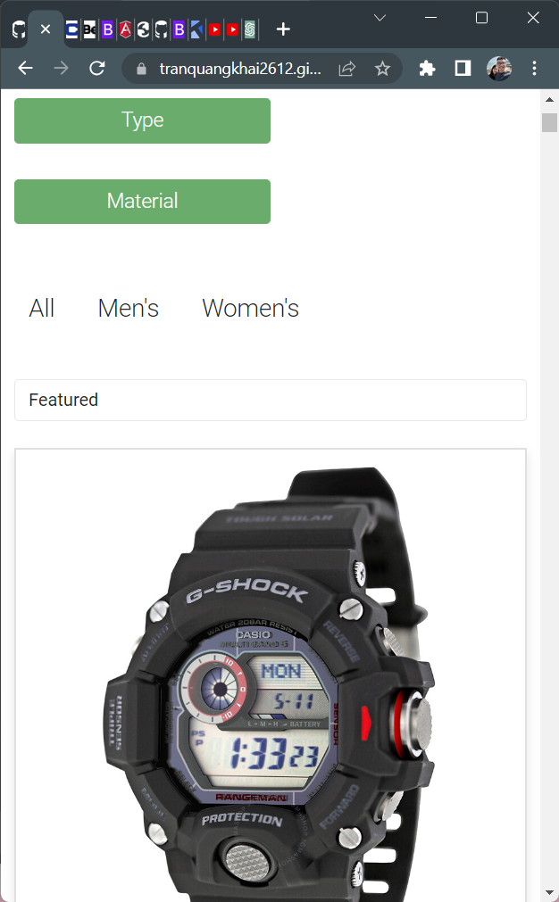

# PART 8: SOURCE CODE WITH COMMENTS

## Slider

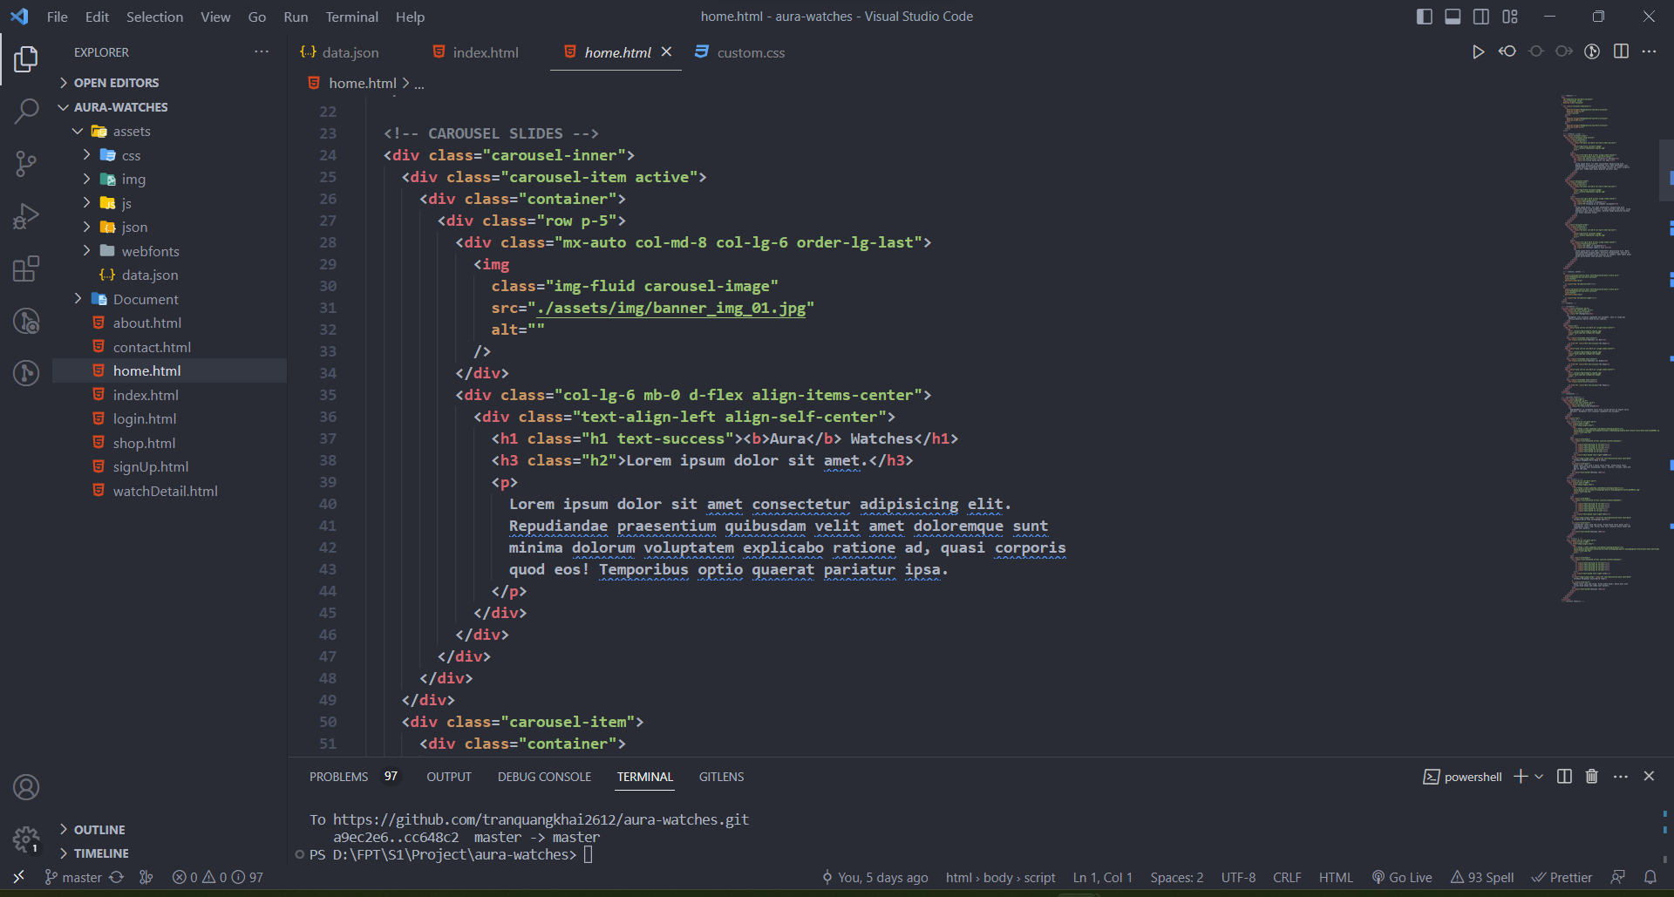

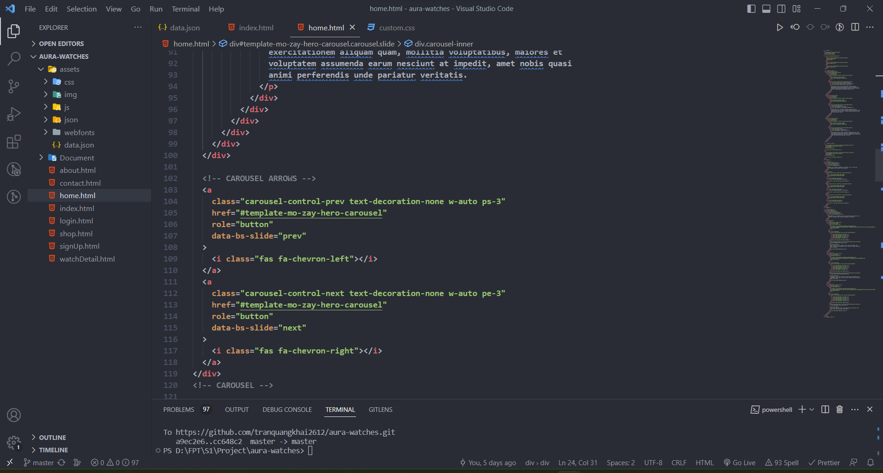

## Filter

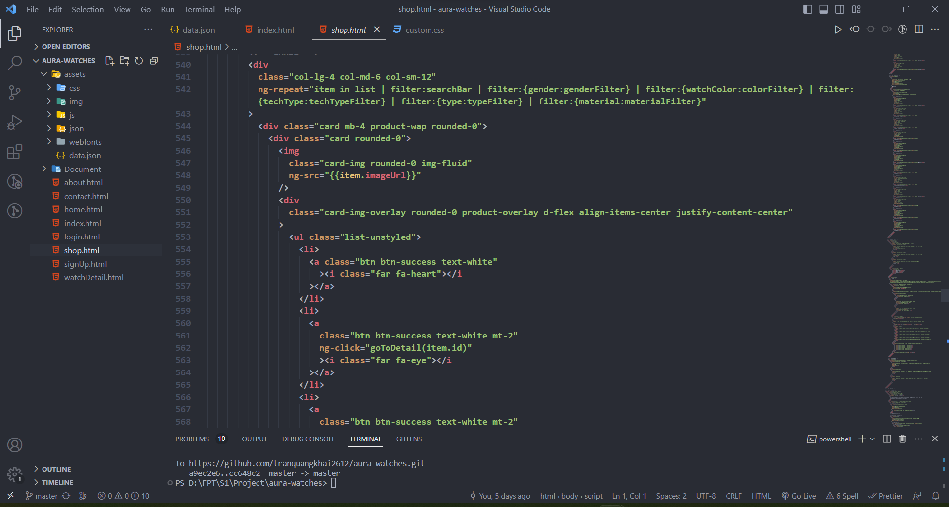

## Show Products

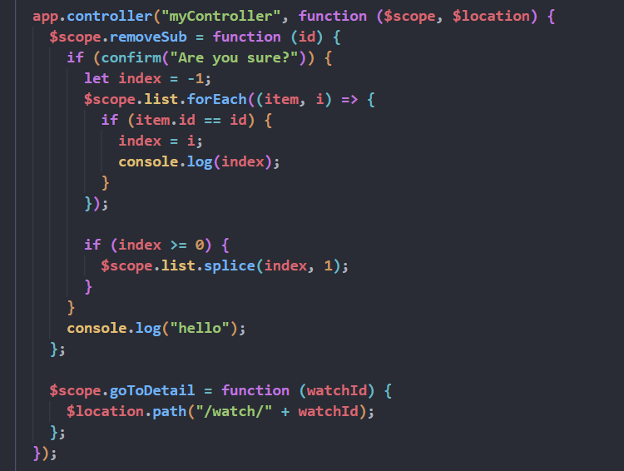

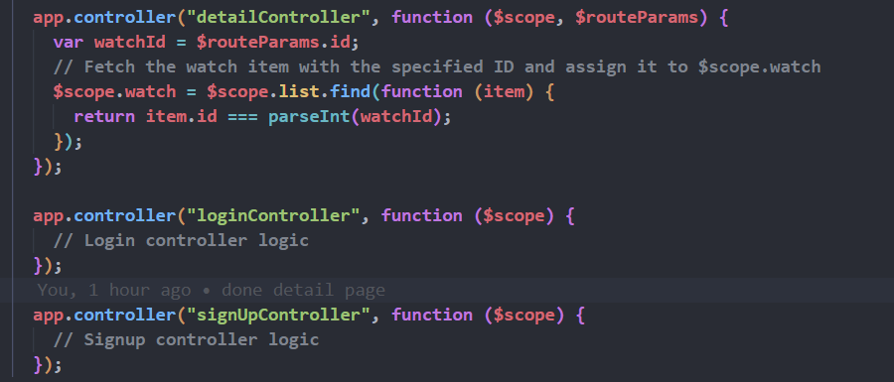

## Routing

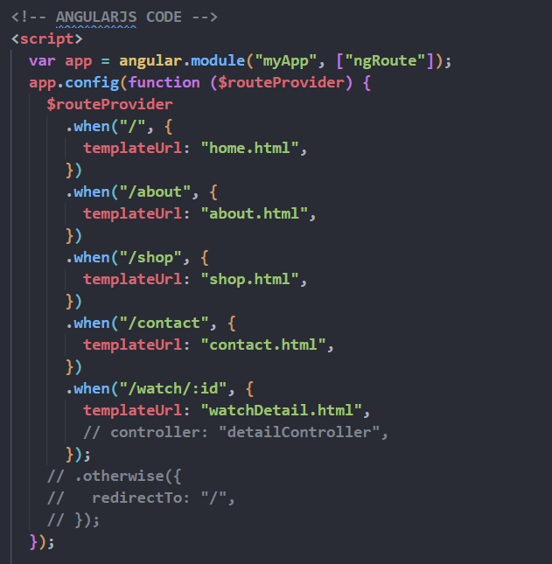

## Json Access

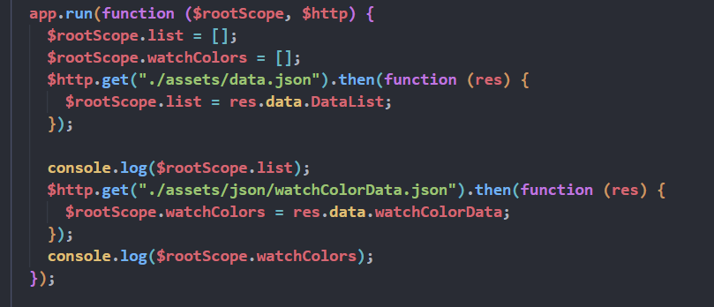

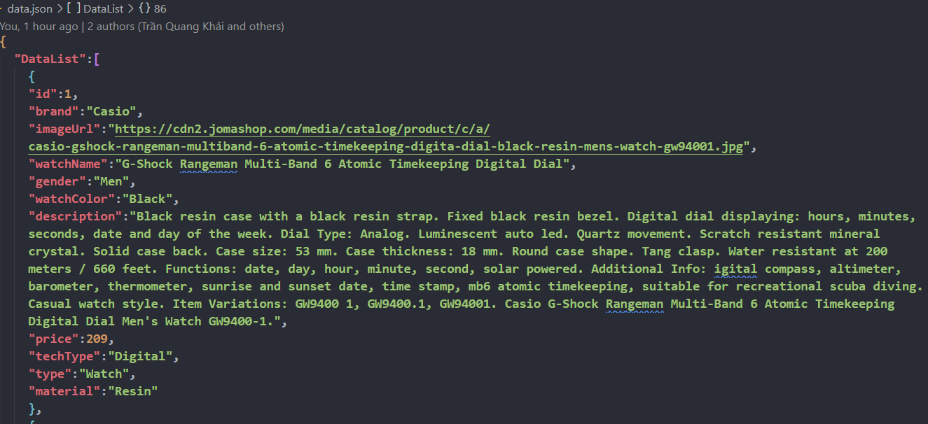

# PART 9: TASK SHEER REVIEW 3

|  |  |  |  |  |  |  |  |
| --- | --- | --- | --- | --- | --- | --- | --- |
| **Project Ref. No.:**  **eP/Advertisement Portal Management**  **System/01** | | **Project Title:** | **Activity Plan Prepared By:** | **Date of Preparation of Activity Plan:** | | | |
| **Sr.**  **No.** | **Task** | **Actual**  **Start**  **Date** | **Actual Days** | **Team**  **Mate Names** | **Status** |
| 1 | Home Page | AURA WATCHES | Khai | 18-June-21 | 1 | Khai | Completed |
| 2 | Product | 20- June -21 | 3 | Khai | Completed |
| 3 | Blog | 18- June -21 | 2 | Hue | Completed |
| 4 | About Us | 20- June -21 | 2 | Hue | Completed |
| 5 | Contact Us | 18-Ju June ly-21 | 2 | Huy | Completed |
| 6 | Service | 20- June -21 | 2 | Huy | Completed |
| 7 | Sign In/ Sign Up | 22- June -21 | 1 | Huy | Completed |
| 8 | Java Script | 23- June -21 | 2 | Khai | Completed |
| 9 | Responsive | 22- June -21 | 1 | Hue | Completed |

|  |  |
| --- | --- |
| **Date:** | |
| Signature of Instructor  Ms. Le Mong Thuy | Signature of Team Leader  Tran Quang Khai |

# 